**Sensor Fusion** helps a sensing robot gain information (understand and track) from its environment. These can be other cars, pedestrians, car barriers.

We will use sensor fusion to help track a person’s position relative to a car with LIDAR and RADAR Data.

**An example of a sensor fusion technique used is called a Kalman** **Filter**.

**LIDAR and RADAR**

**LIDAR: Light Detection and Ranging**

**RADAR: Radio Detection and Ranging**

**RADAR Advantages and Disadvantages:**

Radars are used in cars for systems like cruise control, blind spot warning, collision warning, and collision avoidance. Most sensor measure the velocity of an object by taking the difference between two measurements, but the advantage of RADAR is that it can measure the velocity directly with the use of the Doppler Effect.

The Doppler Effect measures the change in frequency of a radar wave based on whether the object is moving away from you or towards you.

Having the velocity of an object as an independent measured parameter is important to sensor fusion. It makes the fusion algorithm converge much quicker.

Radar waves can also be used for localization by generating radar maps of the environment. Radar waves only bounce off of hard objects, which means that it can be useful to map objects obscuring the vision. Radars are good at mapping objects obscured by other vehicles by reflecting waves underneath a car.

Radar is the sensor that is the least effected by rain or fog. It has a wide field of view of 150 degrees and range 200+ meters.

Radars have a low resolution when compared to LIDAR data, especially in the vertical direction.

Lower resolution means that reflections from static objects can cause problems. This is called Radar Clutter. To avoid this, most automotive radars ignore static objects (like manhole covers, and tin cans).

LIDAR ADVANTAGES AND DISANDVANTAGES:

Uses an Infared Laser Beam to determine the distance between the sensor and nearby objects. Most current LIDARs use light in the 900nm wavelength Range, while some use longer wavelength ranges to perform better in rain and Fog.

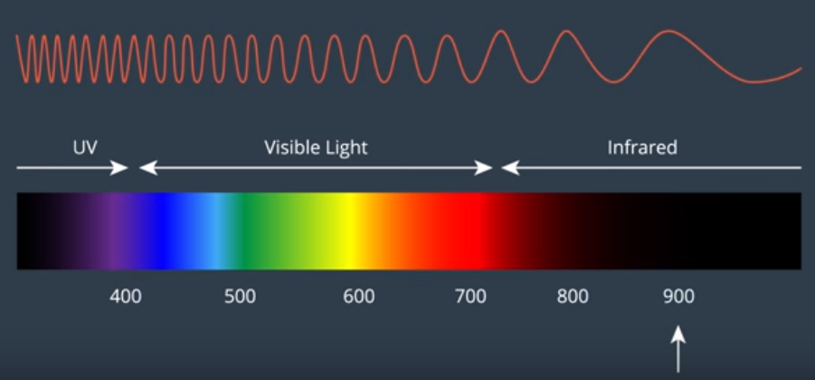

Current Lidars are rotatate on a swivel (similar principle to a phased array radar) to scan a laser beam across the field of view. The reflections of the light pulses emited are sensed and with that data, a point cloud is created to represent detected objects.

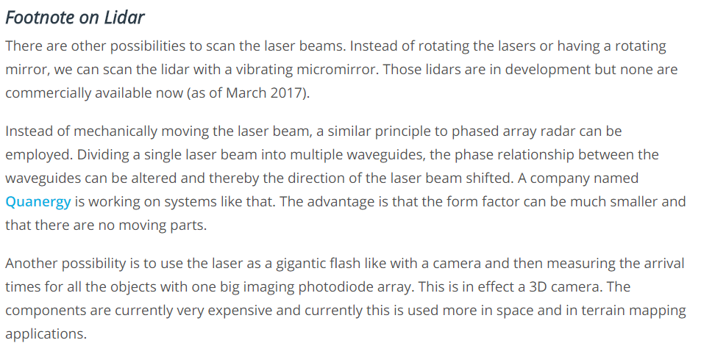

Lidar has a more focused laser beam, which leads to a much higher spatial resolution than radar. There is also a much greater spatial resolution vertically than radar. There is also a higher density of LIDAR points per layer that leads to the higher spatial resolution. Current Lidars cant measure velocity directly, meaning it has to use the difference between two scans. It is also effected by weather conditions and dirt on the sensors much more than with RADAR. They are also much larger than the other sensors, making it harder to integrate into a vehicle.

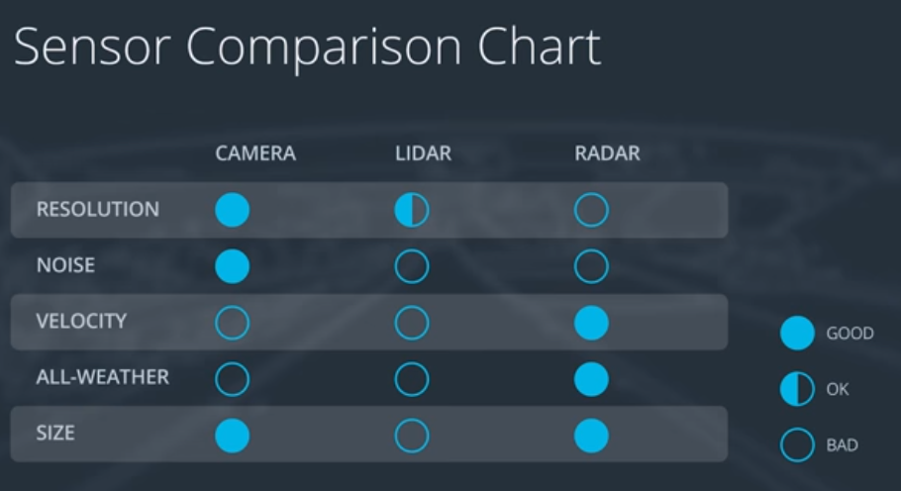

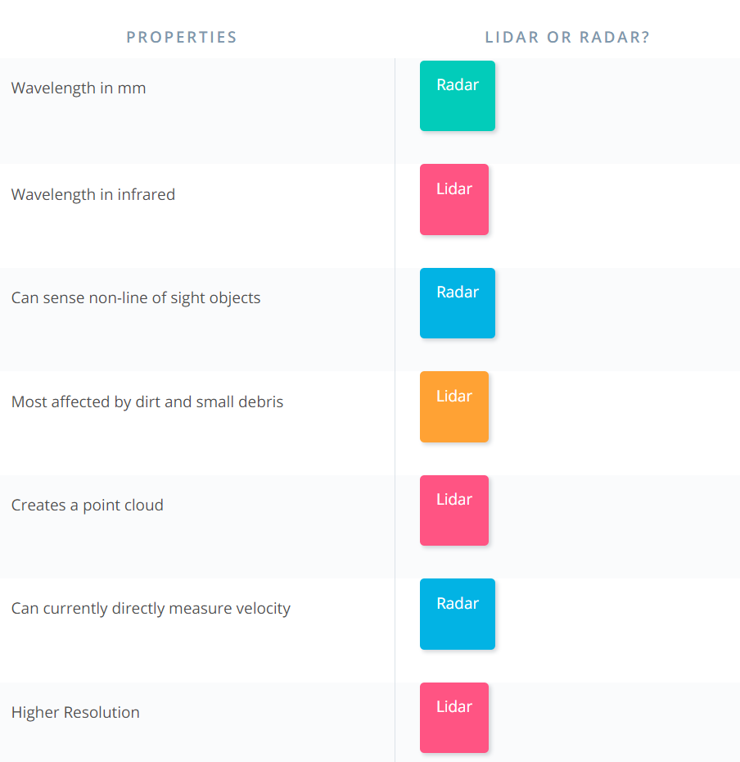

**Sensor Fusion** is only as useful as the hardware itself. More data means less uncertainty of the position of nearby objects. As hardware gets cheaper, more of it can be used on robots and vehicles to gain more data, making the uncertainty of the position of nearby objects drop drastically.